Cloud Computing - Platform as a Service Lab

Email: **tramnnt.139@gmail.com**

Full name: Nguyễn Thị Ngọc Trâm

Student ID: 21C11036

PaaS provider URL: <https://developer.salesforce.com/>

Application URL for admin: <https://hcmus2-dev-ed.develop.lightning.force.com/lightning/r/User/0052w00000Bx24iAAB/view>

Admin email or username: [tramnnt.139@gmail.com](mailto:tramnnt.139@gmail.com)

Admin password: ngocTram1309$

Screenshot of admin UI:

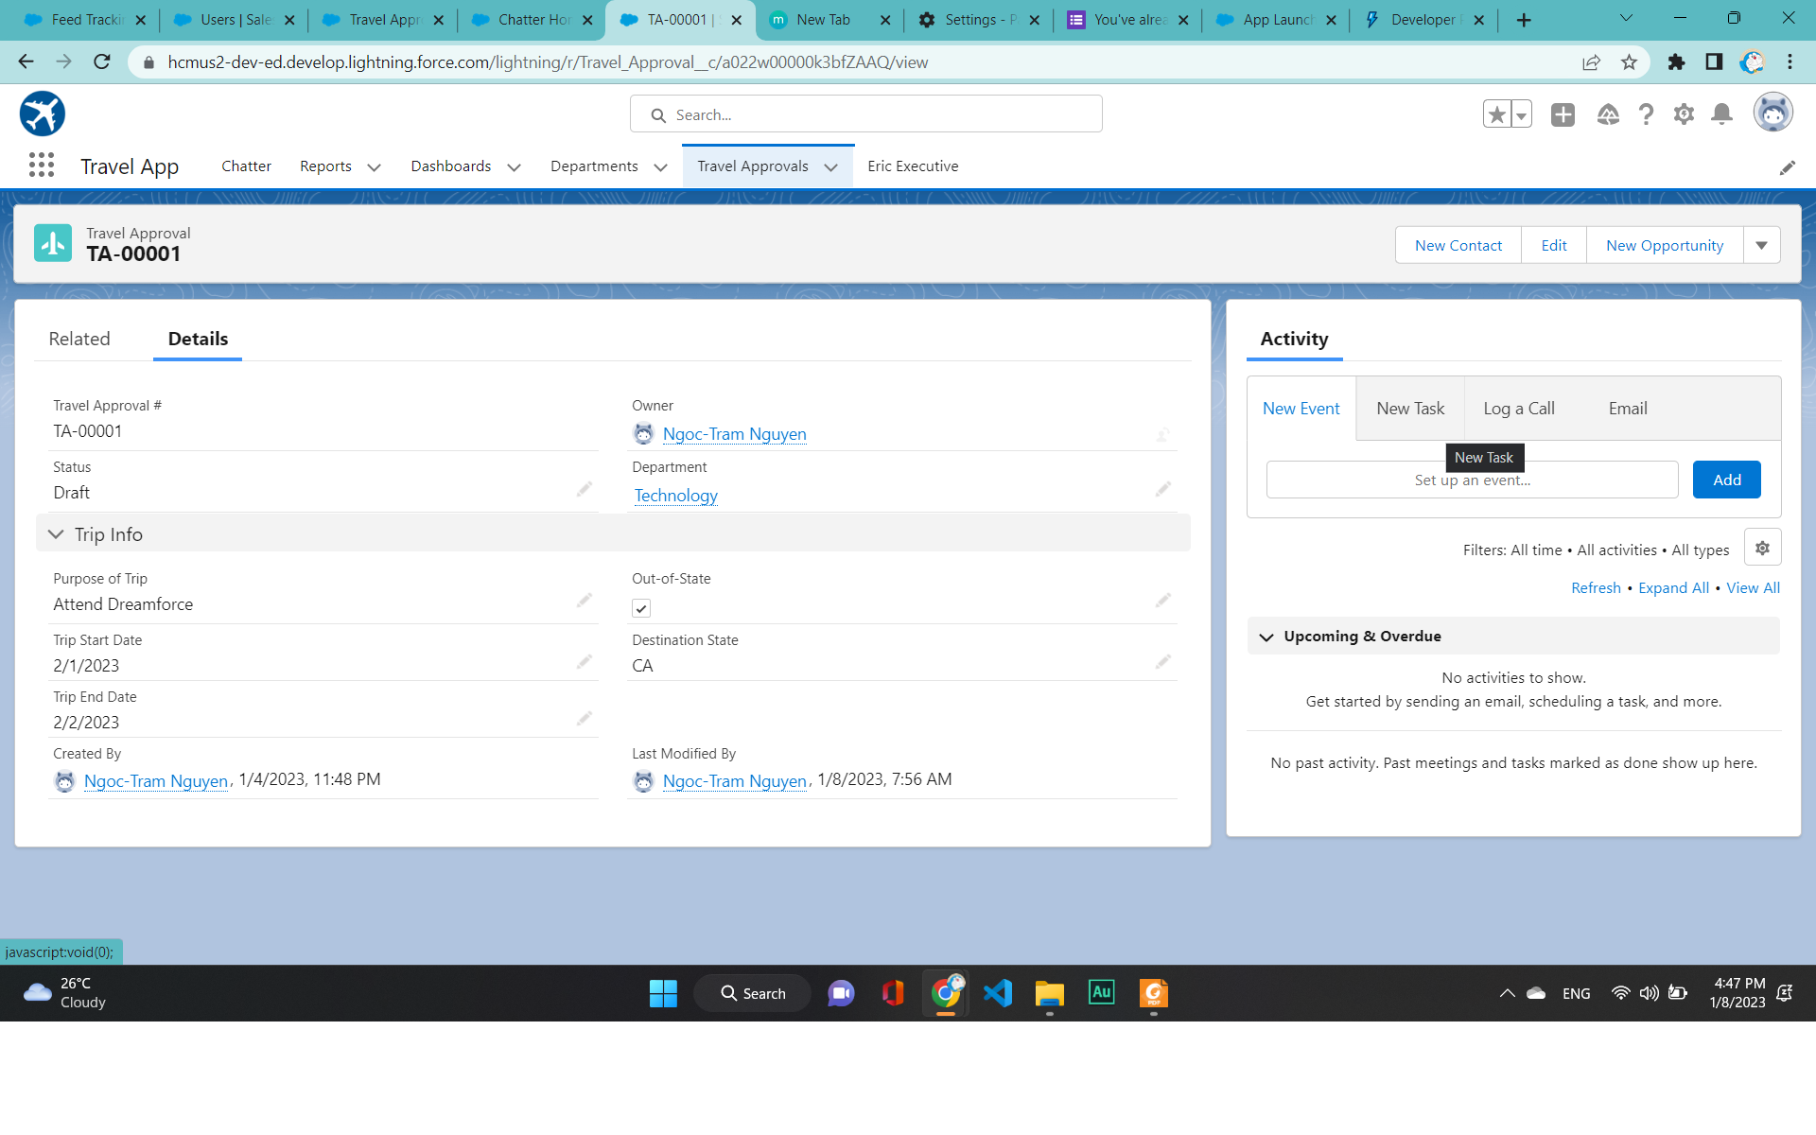

Application URL for user: <https://hcmus2-dev-ed.develop.lightning.force.com/lightning/r/Travel_Approval__c/a022w00000k3bfZAAQ/view>

User Email or username:

[21c11036@student.hcmus.edu.vn](mailto:21c11036@student.hcmus.edu.vn)

User password: ngocTram13

Screenshot of user UI: